1. Trainee download data (Hands on - Model_vs_GSMaP.xlsx) from LMS.
2. Trainee do eyeball verification and make analysis about it (Hands on - Model_vs_GSMaP.pps)
3. Trainee summarize the verification results and decide the best model in that case.
4. Point 3 should be documented in presentation file (including some analysis/explanation)

**Output:**

1. A presentation file as a summary of verification process
2. This hands on has to be done on Wednesday, 9 June 2021. Please send me question(s) if you’re still not clear about this hands on.

Teknik Eye ball merupakan representasi dari penilaian kualitatif. Secara kualitatif, keseluruhan model terlihat under estimate dibandingkan dengan data observasi GSMAP.

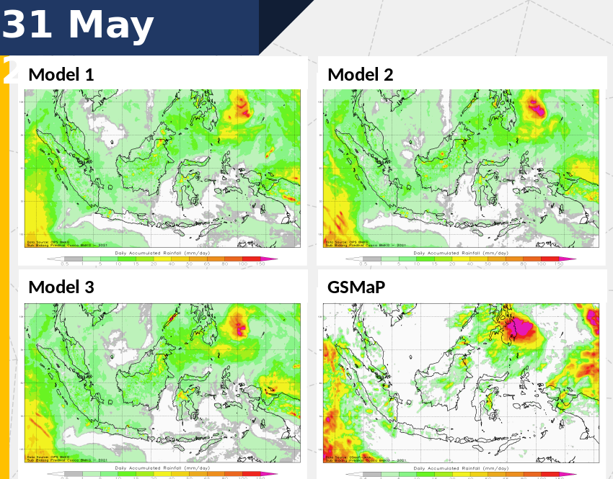

Precipitation Forecast for 31th May 2021

**Qualitative Analysis**

Eyeball technique represents qualitative measurement of the prediction performance. Spatially, all model performs underestimate results, compare to GSMAP observational data.

All models from **intensity analysis** shows less variation. Model 1 seems the most similar convective pattern but no models have exact center of Circular convective pattern (Philiphine and vicinity) and it can results higher value on some significant areas.

**Spatial analysis** perform that precipitation model more spreaded than GSMAP and spatially look more continue over the sea while GSMAP data shows the slight rainfall events tend to concentrate mostly inside the islands. The most reliable model in this section is Model 1. **Area coverage** by all models spatially seem wider than GSMAP. there are no models perform exact position but interestingly we suspect that GSMAP has parallax shifting. So it can causing different centroid position of precipitation area.

**Quantitative Analysis**

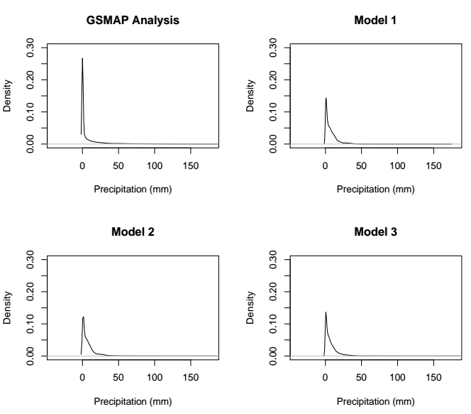

Density Function of Precipitation data on 31th May 2021

**Density Function** shows that no models can catch maximum GSMAP Precipitation data. This result confirms Qualitative Analysis that all model are underestimate. Model 1 performs the best in maximum values.

|  |  |  |  |
| --- | --- | --- | --- |
| **Model** | **Accuracy** | **POD** | **FAR** |
| Model 1 | 0,87 | 0,31 | 0,33 |
| Model 2 | 0,86 | 0,33 | 0,44 |
| Model 3 | 0,86 | 0,32 | 0,43 |

**Statistics of Models**

Statistics exhibit that Model 1 is the best performance.

**Resume:**

By the qualitative and quantitative analysis, Model 1 is the best performance

Supplemen